**SSCBS**

**MAYANK CHOPRA**

**ROLLNO -23719**

**XAMPP SETUP**

**POC- Go the browser type xampp process and click on download for windows**

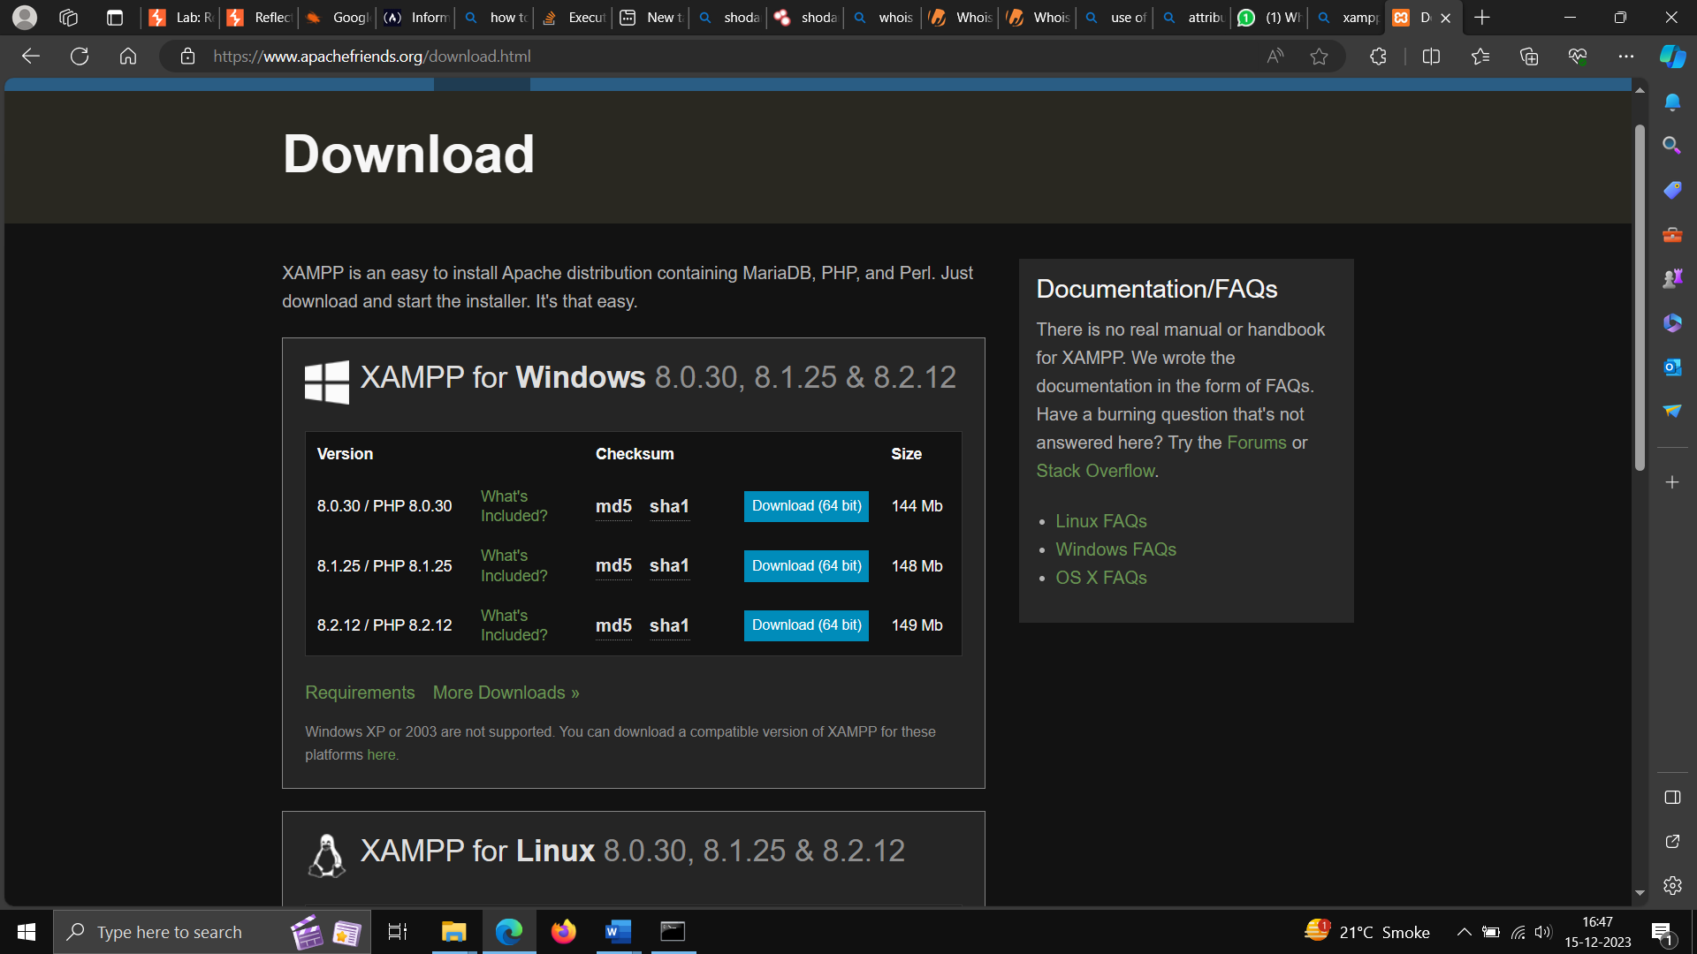

**Also Download VScode or Sublime for HTML page and place that folder in htdocs of xampp for enabling php**

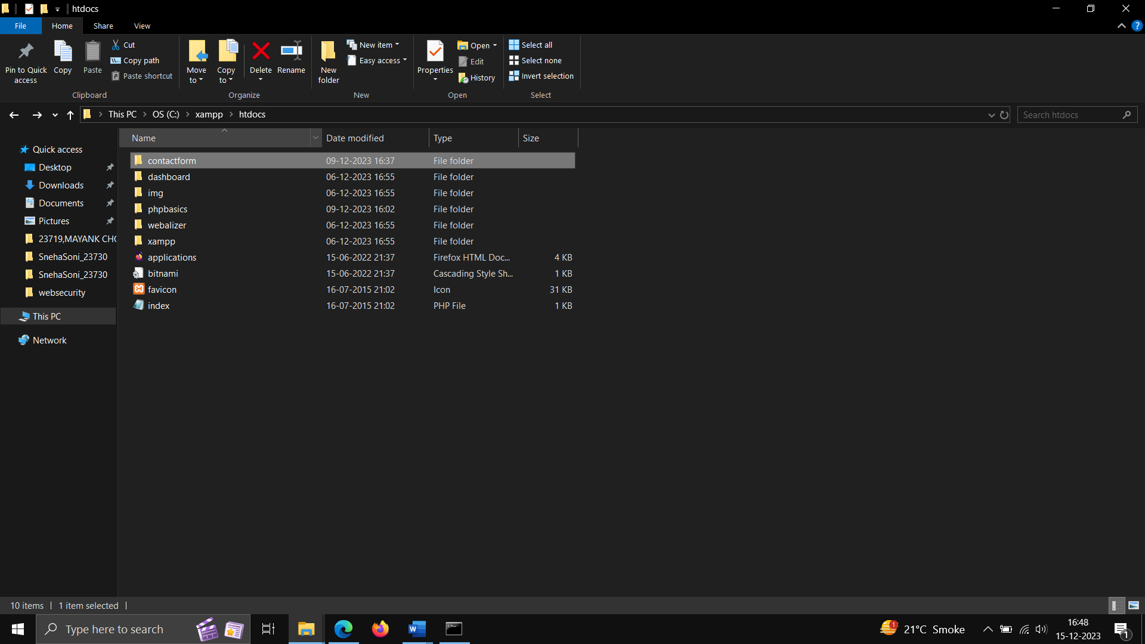

**Create the database as per the Requirement as shown below**

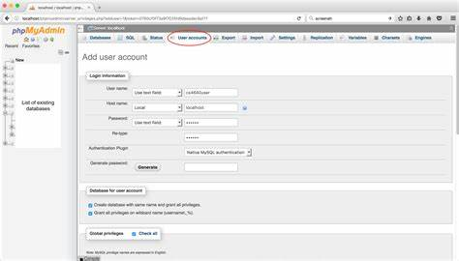

**MY SQL**

**Go the browser and download the my sql oracle server by login into oracle account –**

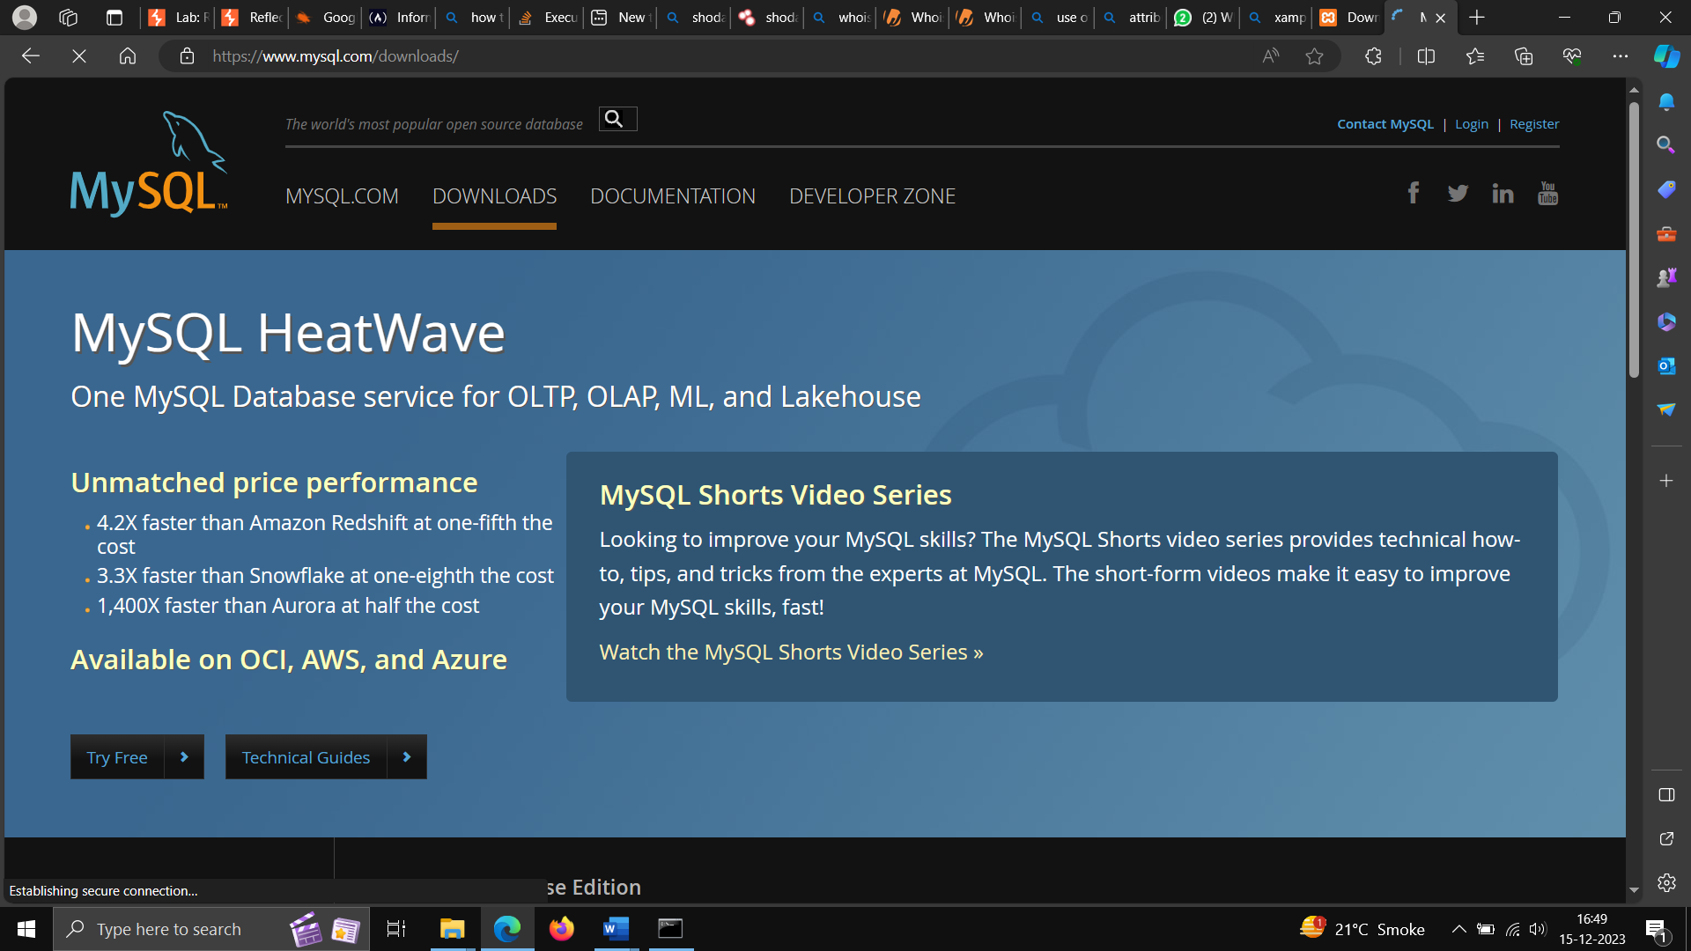

**Further after downloading click on next and wait for installing**

**Start the command line for access sql using same loginid and password that was used in installation**

**Or use mysql -u root -p in bin folder in of my sql if not working.**